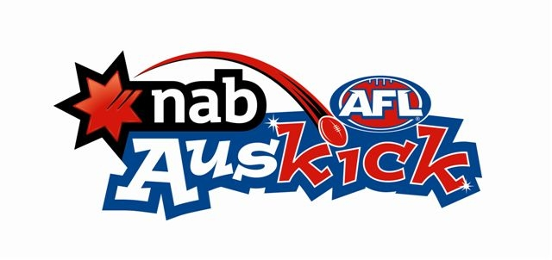
2018 NAB AFL AUSKICK - RULES FLOW CHART
PP – Year 2 NAB AFL Auskick Program
Please note: participants must be 5 as of June 30th As at 1st Feb 2018

 | NAB AFL Auskick Program for PP - Yr2’s
1. Playing Field | Half senior size. Approx. 80m x 50m  Divide into three zones –30/20/30m
2. The Team | 6 or 9-a-side preferred – no rucks and rovers. Unlimited reserves. Rotate players every quarter.
3. Playing Time | Up to 4 x 10 minute maximum quarters
4. Start of Play | A. Ball up between 2 centre players  B. Players should be approximately equal size  C. Players cannot take full possession out of ruck contests.
5. After a goal | As in 4. Different players contest the ruck each time.  Goals can only be kicked by players in forward zone.
6. Scrimmage | No diving on ball. Umpire stops play. Free kick awarded to nearest opponent.
7. Out of Bounds | A. From a kick. Kick awarded to nearest opponent.  B. If doubt as to which team kicked the ball. Ball up 5m in  C. Off hands or body - ball up 5m in from boundary  D. Full possession rule.
8. Tackling | Players cannot hold with hands, knock out of hands, push in side, steal the ball. Players given every opportunity to deliver ball i.e. No harassing.
9. Bumping | No deliberate bumping. No deliberate contact is permitted.
10. Barging | Barging, fending off or chopping with hands passed opponents is NOT allowed. A free kick shall be awarded.
- Stealing/  Smothering/  Harassing/  Possession rule | Not allowed. The ball is possessed by the act of catching it, grabbing it or placing two hands on it when it is on the ground. Once the ball is possessed, all other players must back off to allow the player with the ball to kick or handball uncontested.
12. Shepherding | Player not permitted to push, shoulder or block opponent not in possession of the ball.
13. Mark | Any reasonable attempt to catch ball directly from kick irrespective of distance travelled. No standing on the mark. No playing on allowed.
14. Bouncing the Ball | Player is permitted to bounce the ball only once then dispose of the ball.
15. Kicking off the Ground | Not permitted to deliberately kick the ball off the ground.
16. Order-off Rule | To be applied. Penalty time is umpire discretion
17. Staying in Position | To stop congestion, umpire to instruct players to stay in zone.
18. Coaches | Coach is allowed on the ground to teach.
19. Spirit of the Game | Players and coaches to shake hands. Umpire to instruct players.
20. The Game | No premiership points, no finals, no ladders, no match results, names of players published
21. Awards | Participation, effort and skill achievement scheme.
22. Clearances | Automatic clearance.
23. Tribunals | No tribunal, discipline is the responsibility of the club.
Please refer to By-Laws and Junior Club Manual for latest version

