Metro North Region
(Claremont, Subiaco & West Perth DFDCs) | Circular X/2018
Claremont Family Fun Day & Junior Club Parade
Audience: | Club Presidents, Secretaries, Registrars & Auskick Coordinators
Date: | 06 June 2018
Distributed by/to: | Email Club Presidents, Secretaries & Registrars
Contact: | Andrew Ridley  Community Development Manager – Metro North  Ph: 0408 298 725 (Office Hours Monday to Friday, 9:00am – 5:00pm  Email: aridley@wafc.com.au

Summary:  - The Claremont Family Fun Day will take place on Saturday 16th June 2018 at Claremont Oval.  - The Claremont Football Club and Claremont District invite all Junior Football Clubs and Auskick Centres to march on the ground before the league game.  - Each junior club will parade around the oval before the start of the league game dressed in their Club  Uniforms (playing or apparel).  - Clubs go into the running to win fantastic prizes judged on the most enthusiastic club- presented by the Claremont Junior Football League  - Free entry to the match will be granted if you present the Claremont FC Family Fun Day Flyer. These will be distributed to all Junior Clubs early next week.  - DRESS IN CLUB GEAR, BE LOUD PROUD AND PROMOTE YOUR JUNIOR CLUB | Action:  - Send this information package to club coaches and team managers  - Please encourage all members within your  Junior clubs/teams to attend to help promote your club and local football.  - Make yourselves and club volunteers aware of the schedule and map.

The 2018 Claremont Family Fun Day will take place on Saturday 16th June 2018 at Claremont Oval. The Claremont Football Club and Claremont District invite all Junior Football Clubs and Auskick Centres to march on the ground before the league game.

Your club and all clubs in the Tigers District have been invited to attend. Each club will parade around the oval before the start of the league game dressed in their club playing uniforms and/or club polo/colours.

By presenting the Claremont FC Family Fun Day Flyer, Football Families will be able to enter the game for free. This flyer admits Mum and Dad for FREE when accompanying a child playing within the Claremont Junior Football League. Please present this flyer at the gate.

There will be prizes given away throughout the day as well as fun activities for the kids both on the ground between matches and around the boundary.

The most enthusiastic club will be crowned at the conclusion of the parade. The prize will include 1st Place (50 footballs), 2nd Place (30 footballs) and 3rd Place (20 footballs) and will be judged on best attended, dressed (club colours) and representation (behaviour).

*Prize decisions are at the discretion of the Claremont District Football Development Council, will be final and cannot be disputed.

Please try and make yourselves available to attend this great day, show your club colours at the footy and support your club and football in the Claremont District. This is a great opportunity promote your club.

Please find attached the match day schedule, club information for announcers and venue layout.

Claremont vs. West Perth, Saturday 16th June 2018
MATCH DAY SCHEDULE

Time of Matches
Colts: 9:00am Reserves: 11.30am League 2:15pm

8:00am: Gates Open

12:30pm: Juniors are asked to begin arriving (if not arriving earlier to watch the Reserves Game). Players and Officials from Junior Clubs to Arrive and be seated in marked areas on grassed banks POSITION A (see attached map)
Clubs are provided the opportunity erect banners and marquees within your designated area. We recommend these are erected prior to 12.30pm.

1:20pm: Junior Clubs to be in position in their club areas.

1:20-1:30pm: Claremont Development Officer will report to each junior club and brief club officials.

1:40pm: Reserves finish

1:42pm: Players and Officials from Junior Clubs follow on to the oval for the parade MOVE TO POSITION B (see attached map).

1:46pm: Claremont enters the arena

1:47pm: West Perth enters the arena

1:50pm: PA instructs Players and Officials from Junior Clubs to move onto the oval – PA begins Parade Day announcements

Parade begins moving along to front inside boundary line to POSITION C before moving to the back of the centre square lined in club groups POSITION D (see attached map).

Cones will be lined up equally spaced in 12 positions marking placement for each clubs to stand.

Clubs to line up behind each cone staying in number order.

2:00pm: Graham Moss to address crowd

2:05pm: PA to announce Players and Officials from Junior Clubs to depart oval
POSITION E (Clubs are asked to depart the ground quickly for game to start on time)

2.15pm: League Match commences
2:30pm: Selection Panel (District Chair, Competition Director, Assistant Competitors/s, Administrator and Development Officer) to meet in Function Room briefly to select top three winners.
Development Officer to enter winners on announcer’s sheet with support from CFC staff.

Half Time: Junior Parade Club Award winner announced

Suggestions:
- Get players wearing club colours and / or uniform
- Engage your club mascots
- Be creative with banners, signs etc.
- Encourage as many members as possible to attend across all age groups

Activities and games will be provided for kids throughout the day. Teams are encouraged to stay and support the Claremont Football Club at this event.

Parade order and Seating Chart

- Claremont JFC
- Cottesloe JFC
- Dalkeith Nedlands JFC
- Marist JFC
- Mosman Park JFC
- North Beach JFC
- Scarborough JFC
- Subiaco JFC
- Swanbourne JFC
- Wembley JFC
- Wembley Downs JFC
- West Coast JFC

(See venue map)
Claremont vs. West Perth
Saturday 16th June 2018
Junior Parade - Venue Map
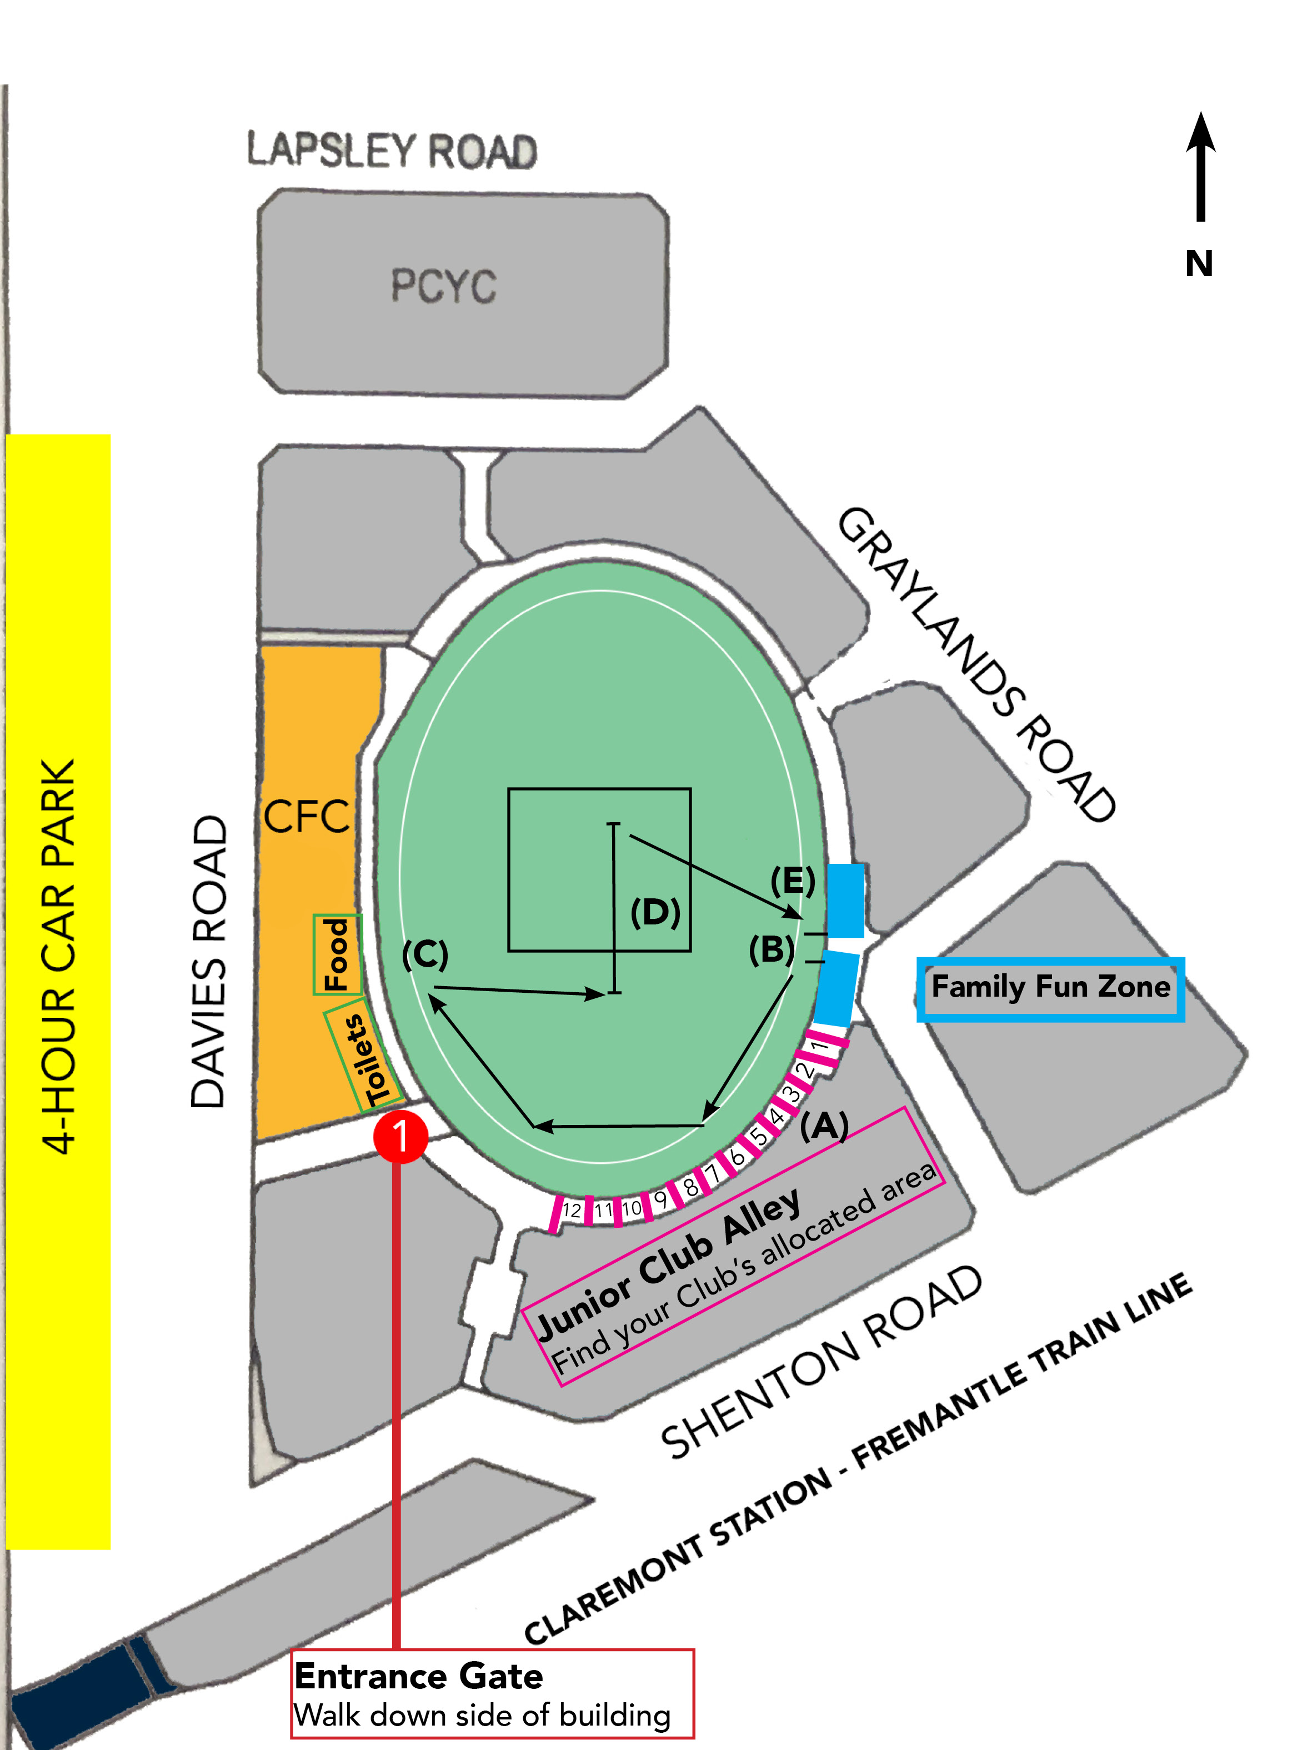

CLAREMONT OVAL
3 DAVIES RD CLAREMONT WA 6010

